Review | Simplify :  $$\frac{10}{15}$$
Review | Simplify :  $$\frac{12}{20}$$
Review | Simplify :  $$\frac{3}{9}$$

Current | 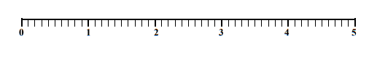  What number is the arrow pointing towards?
Current | What number is the arrow pointing towards?
Current | Plot a point at the following numbers:  1.3  2.8  4.7

